SEMESTER ONE
Papers written by Australian Maths Software

YEAR 12
MATHEMATICS SPECIALIST
REVISION 3
UNIT 3
2016
Section Two
(Calculator–assumed)

Name: _________________________________

Teacher: ________________________________

TIME ALLOWED FOR THIS SECTION

Reading time before commencing work: 10 minutes
Working time for section: 100 minutes

MATERIAL REQUIRED / RECOMMENDED FOR THIS SECTION

To be provided by the candidate
Standard items: pens, pencils, pencil sharpener, highlighter, eraser, ruler.
Special items: drawing instruments, templates, notes on up to two unfolded sheet of A4 paper, and up to three calculators approved for use in the WACE examinations.

IMPORTANT NOTE TO CANDIDATES
No other items may be taken into the examination room. It is your responsibility to ensure that you do not have any unauthorised notes or other items of a non–personal nature in the examination room. If you have any unauthorised material with you, hand it to the supervisor before reading any further.

To be provided by the supervisor
Question/answer booklet for Section Two.
Formula sheet retained from Section One.
Structure of this examination

 | Number of questions available | Number of questions to be answered | Working time (minutes) | Marks available | Percentage of exam
Section One  Calculator—free | 5 | 5 | 50 | 50 | 35
Section Two  Calculator—assumed | 12 | 12 | 100 | 100 | 65
Total marks |  |  |  | 150 | 100

Instructions to candidates

1. The rules for the conduct of this examination are detailed in the Information Handbook. Sitting this examination implies that you agree to abide by these rules.

2. Write your answer in the Question/Answer booklet.

3. You must be careful to confine your responses to the specific questions asked and to
follow any instructions that are specific to a particular question.

4. Spare pages are provided at the end of this booklet. If you need to use them, indicate in the original answer space where the answer is continued i.e. give the page number.

5. Show all your working clearly. Your working should be in sufficient detail to allow your answers to be checked readily and for marks to be awarded for reasoning. Incorrect answers given without supporting reasoning cannot be allocated any marks. For any question or part question worth more than two marks, valid working or justification is required to receive full marks. If you repeat an answer to any question, ensure that you cancel the answer you do not wish to have marked.

6. It is recommended that you do not use pencil, except in diagrams.

7. The Formula Sheet is not to be handed in with your Question/Answer booklet.

6. (19 marks)
(a) Two particles, P₁ and P₂, are travelling in circular paths as defined by the
Equations
(i) Show that both paths have the same Cartesian graph and explain why.
(4)

(ii) Sketch the path of the particles below. (2)
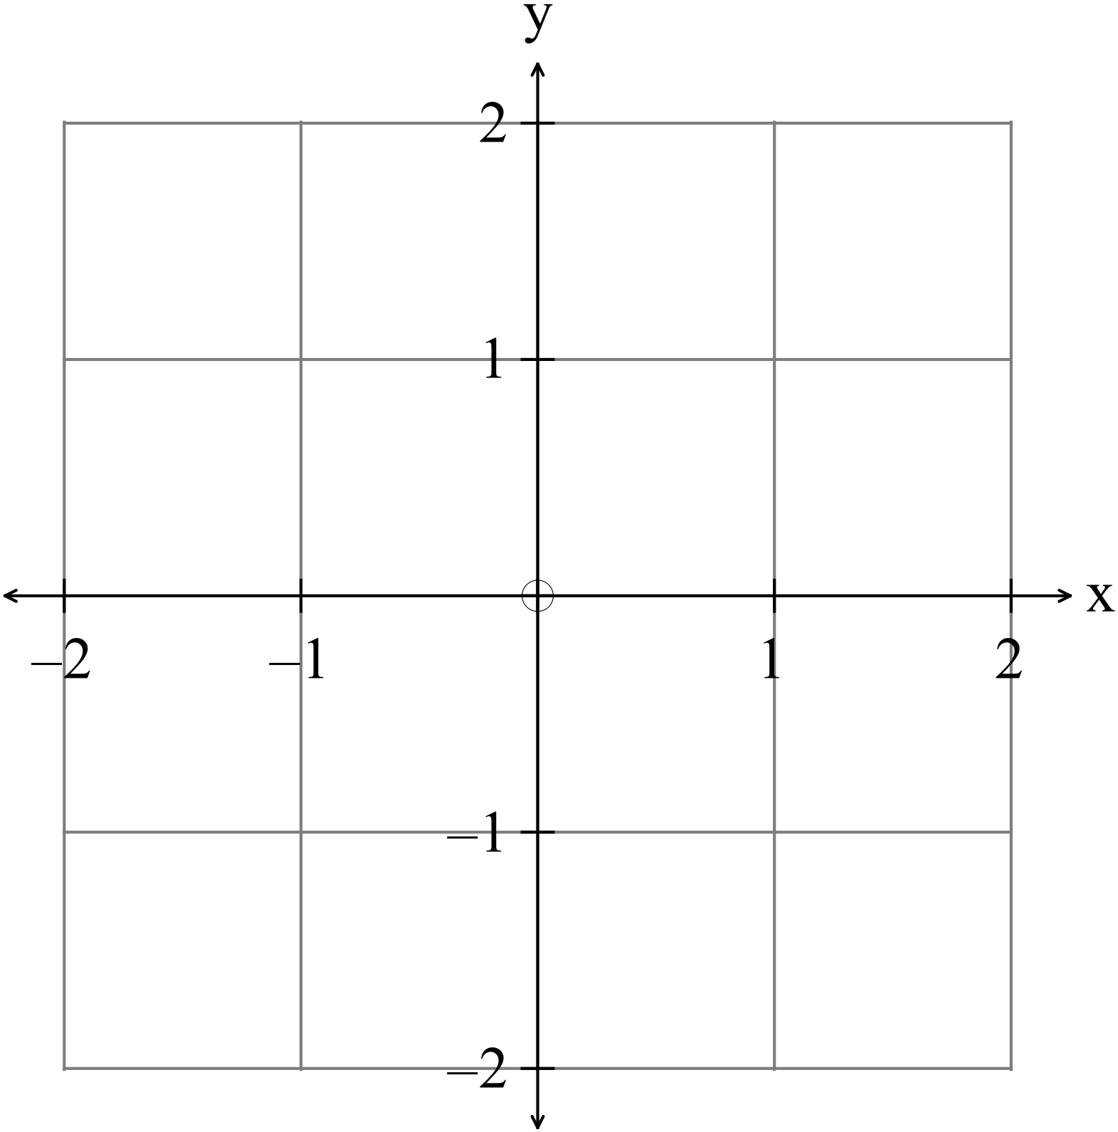
(iii) Determine the starting point and direction of travel for both particles. (2)

(iv) How far apart are the particles at 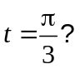 (2)

(b) The position vector of a particle at time is given by
The relationship is graphed below:
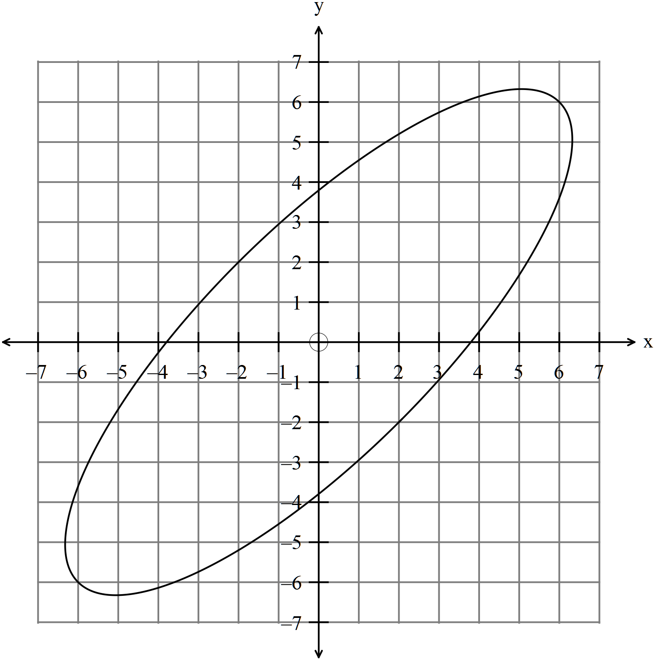
(i) Find the expressions for 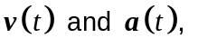the velocity and acceleration of
the particle and hence show that 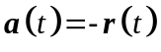. (4)

(ii) Find an expression for 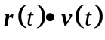 (3)

(iii) For what values of for 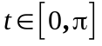 is the position vector perpendicular to
the velocity vector? (2)
7. (7 marks)
Assume 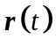is the position vector, 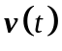 is the velocity vector and 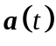 the
acceleration vector for the motion of a particle.
(a) Evaluate 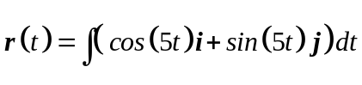 given 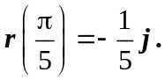 (3)

(b) Determine the expression for given . (2)

(c) Using the results of (a) and (b) find the position vector and the velocity at 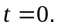
(2)

8. (3 marks)

Find a unit vector that is normal to the plane containing the points 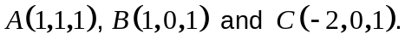 (3)
9. (6 marks)
(a) Given the points
find the coordinates of point such that 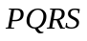 is a parallelogram (in cyclic
order). (3)

Given 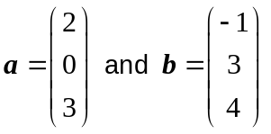
(b) (i) evaluate 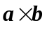 (1)

(ii) explain how to find the area of the triangle 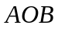 given 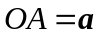 and
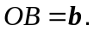 (2)

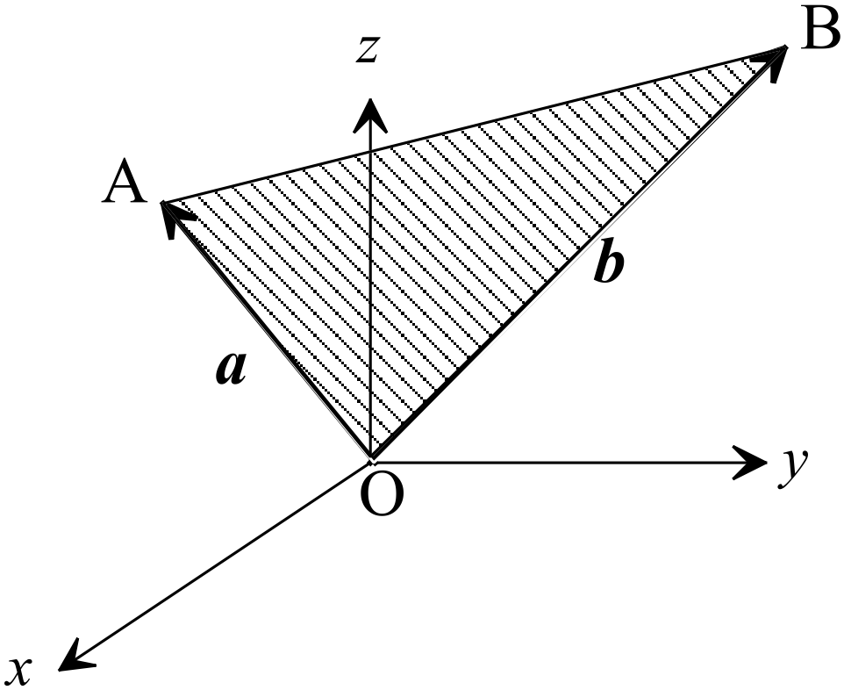

10. (7 marks)
(a) (i) Find the vector equation of the plane through 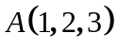 and that contains
the line 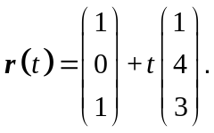 (3)

(ii) Determine whether or not the point 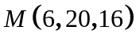 belongs to the line in (i). (1)

(b) John and Jack are twins, fifteen years old and competitive. They both see the birthday parcel their Dad hid on the branch of a tree at 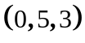 at the same time.
John is at 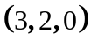 and leaps for the parcel with a velocity of 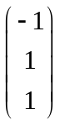.
James is at 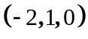 and leaps for the parcel with a velocity of 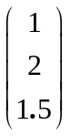.

(i) How long does it take John to reach? (1)

(ii) Who gets to the parcel first? (1)

(iii) Which boy, John or Jack moves with the greatest speed? (1)

11. (6 marks)

(a) Find the constant such that 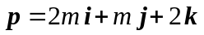 is perpendicular to 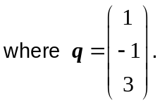 (2)

(b) (i) Given 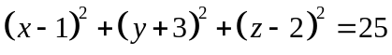 is the Cartesian equation of a
sphere, determine whether or not the point 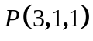is inside, outside or on
the sphere. (2)

(ii) Determine the vector equation of the sphere with Cartesian equation
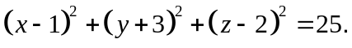 (2)
12. (6 marks)

A ball roll across the top of a table with a speed of 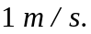
The top of the table is exactly 1 metre above the floor.
Gravity exerts an acceleration of 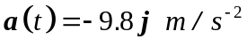.
(a) Exactly how far from the edge of the table does the ball hit the floor? (4) (4)

(b) How long did it take the ball to hit the floor? (2)

13. (12 marks)
(a) Define the set of points shaded on the set of axes below. (3)

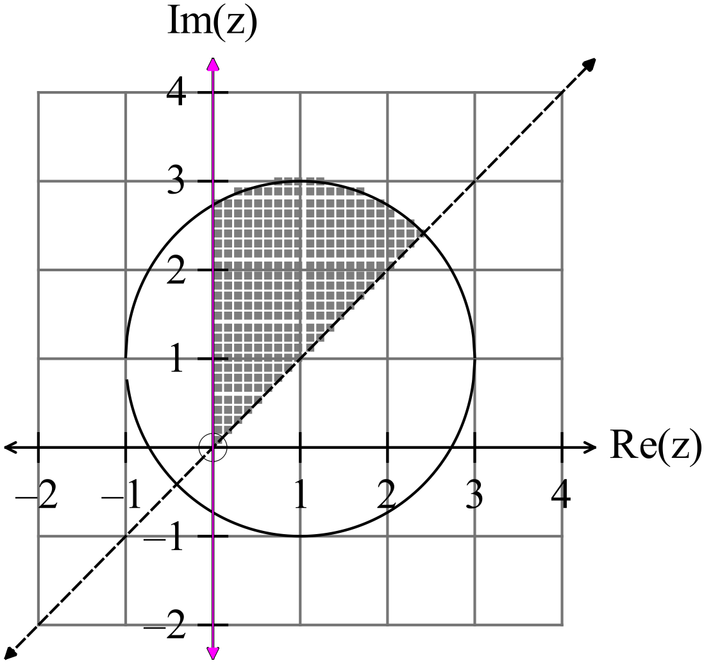

(b) Sketch 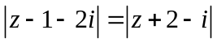 on the set of axes below. (3)
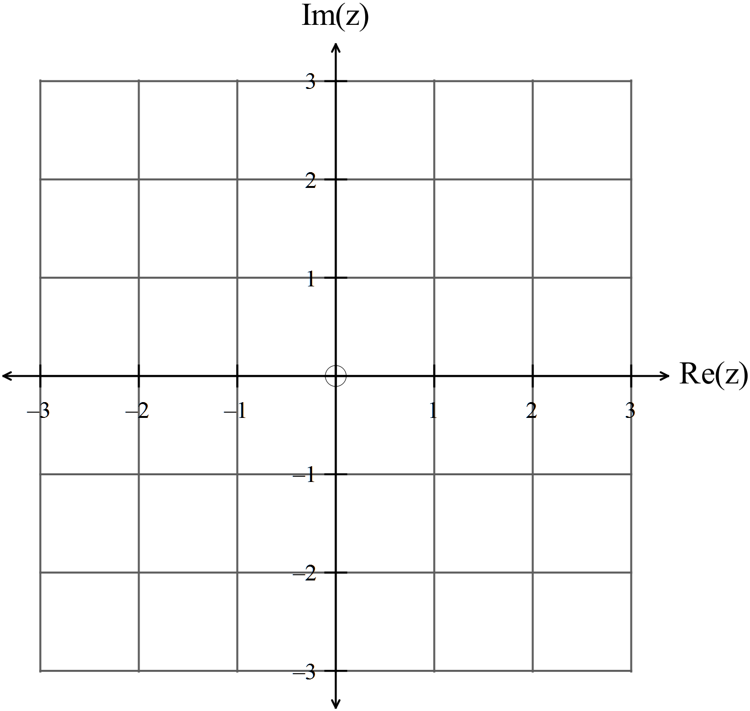

(c) (i) Simplify 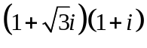. (1)

(ii) If 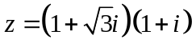 show that 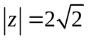 and 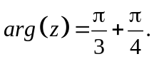 (3)

(iii) Hence show that 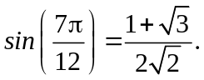 (2)

.

14. (17 marks)

(a) Given 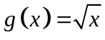
(i) Explain exactly why an inverse exists for the function . (2)

(ii) Sketch the function 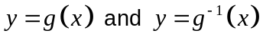 on the set of axes below.
Label each graph. (2)
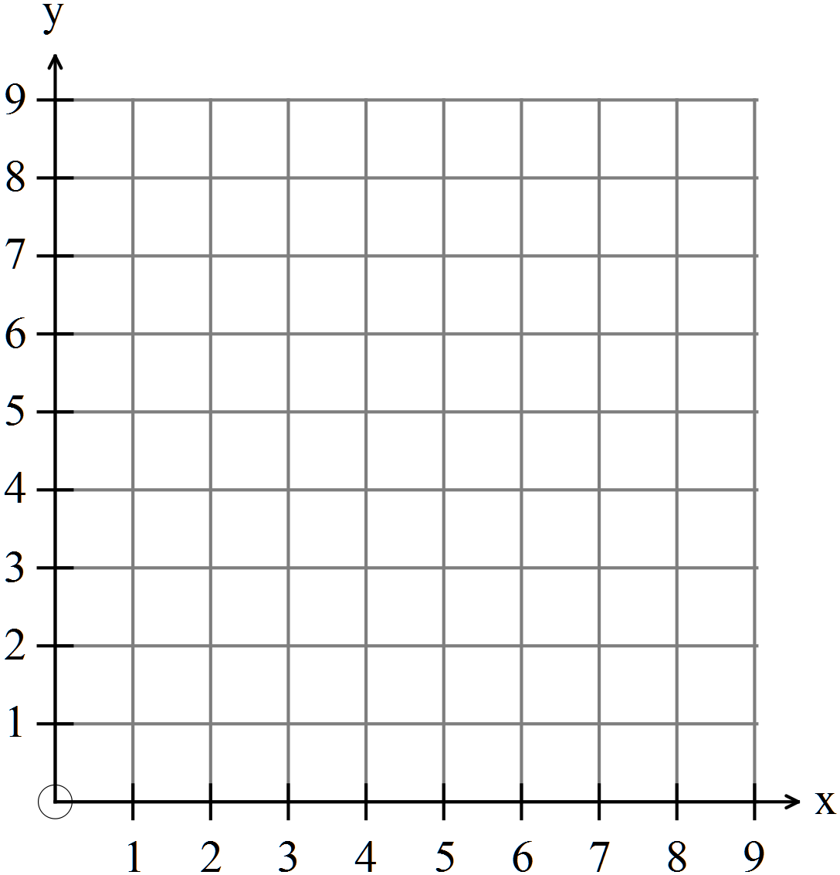

(iii) Determine the equation and the domain and range of 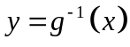. (2)

(iv) Find 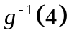. (1)

(b) Given 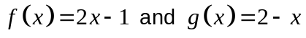 show that 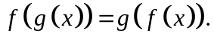 (2)

(c) Given 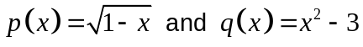
(i) find an expression for 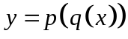 and state the values of for which the
composite function is defined. (3)

(ii) find an expression for 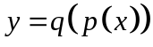 and determine whether or not
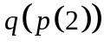is defined. (3)

(iii) state the range of . (2)

15. (8 marks)

(a) Consider the graphs of 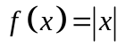 and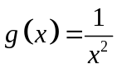.

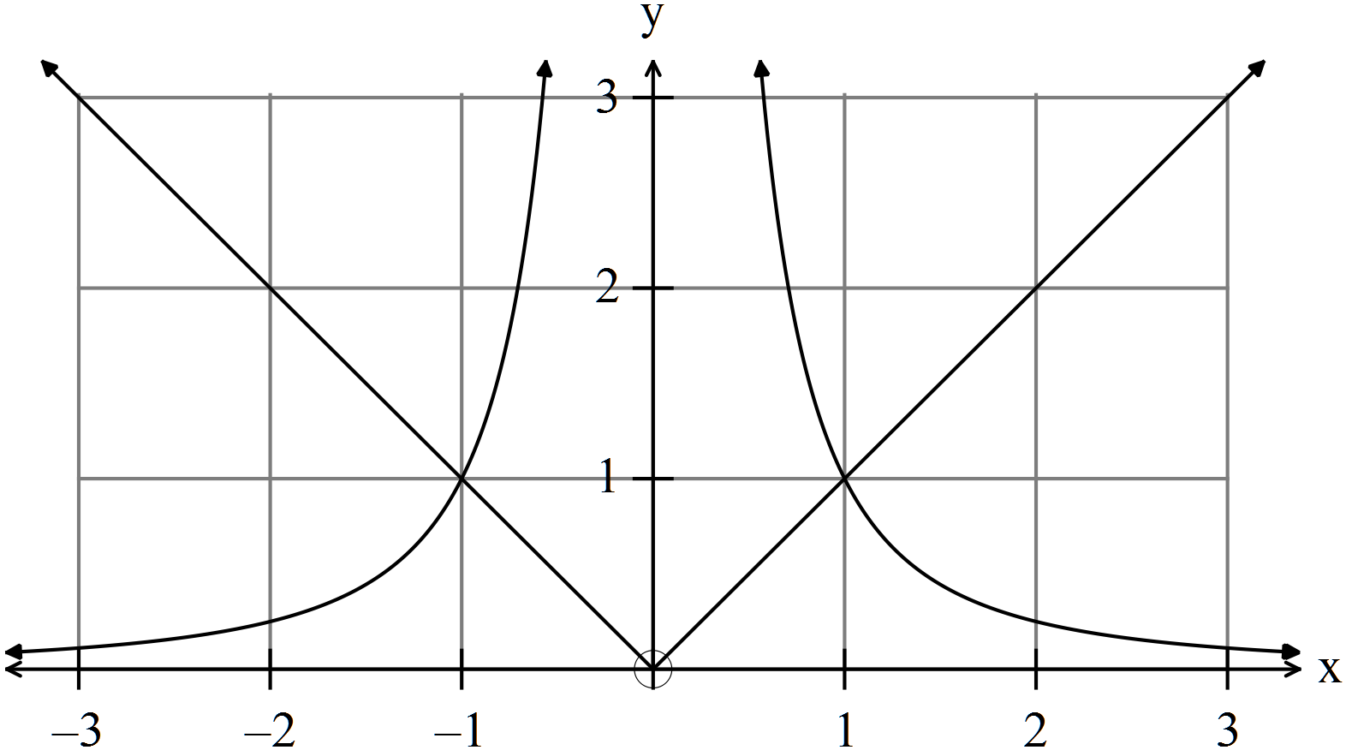

(i) Write down the solutions to 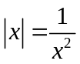. (1)

(ii) Shade on the number line below the values of such that 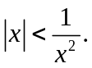 (2)

(b) Solve the equation 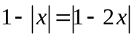 (5)

16. (4 marks)

Determine the equation of the function graphed below: (4)

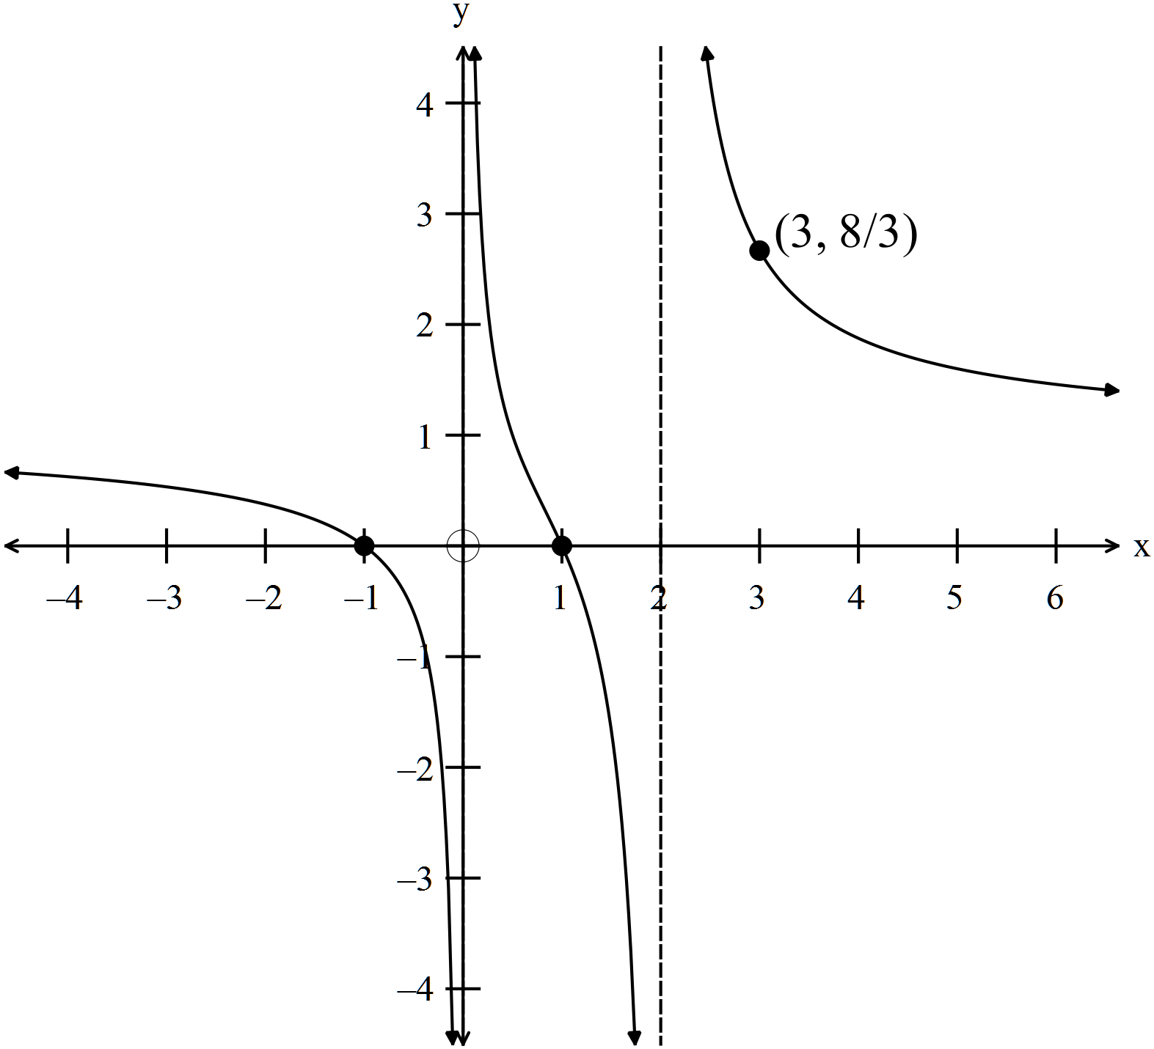

17. (5 marks)

Use de Moivre’s Theorem to prove that .

END OF SECTION TWO

